Code
One of my hobbies is also programming in a while, but not often. I can do a code monitoring if needed or the customer error checking or so.
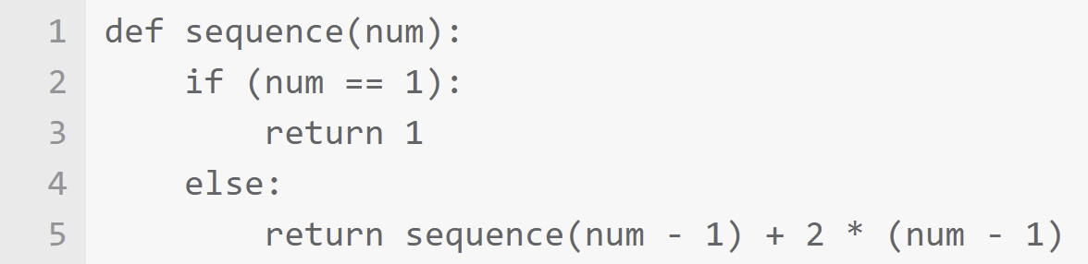
At the moment i have “stayed” using web platforms - “LAMP” mostly.
LAMP ---- Linux + Apache + MySQL (or Maria SQL) + PHP

Assembler
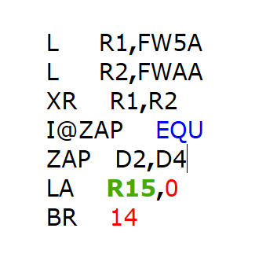
We are all “assembled” some how, by bits and bytes (or molecules, etc ) as described in the language of the DNA, like something here below.
I don't know the assembler language by myself, but I can use some simpler languages if I have the need to use it.
Prefer PHP or Python languages, with some MySQL (or MariaSQL), CSS and HTML. A bit understand also the JavaScript language, can read it, but not to create code “by my heart”.

Analytics or analysis, or rather semiotics
I like to reflect on various “topics that arise in life” from time to time. Well, I mostly use my own thoughts or my own analytical skills for this.
But sometimes I also “borrow” some quotes written by others, which I have found here and there throughout my life.

